REGISTER FOR IBM CLOUD

|  |  |
| --- | --- |
| DATE | 01 NOVEMBER 2022 |
| TEAM ID | PNT2022TMID17753 |
| PROJECT NAME | DEVELOPING A FLIGHT DELAY PREDICTION MODEL BY USING MACHINE LEARNING |

LOGIN PAGE:

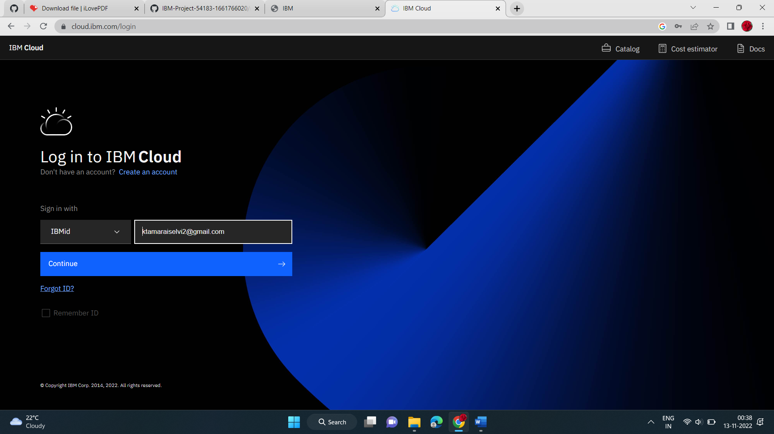

IBM CLOUD:

